|  |  |
| --- | --- |
| **Project – External Documentation** |  |
| COMP6115 | COMP6115001  Object Oriented Analysis & Design |
| *Odd Semester Year 2024/2025* |

* Project Title

CaLouselF

* Introduction

CaLouselF is a comprehensive marketplace application developed using Java and JavaFX, designed to facilitate seamless buying and selling interactions between users. The application implements a robust role-based access control system, featuring distinct interfaces and functionalities for buyers, sellers, and administrators.

* Report / Documentation

1. **Authentication System**

The login screen provides secure authentication with the following features:

* Clean and intuitive user interface
* Username and password validation
* Error messaging for invalid credentials
* Direct access to registration for new users
* Special admin authentication pathway

1. **User Registration**

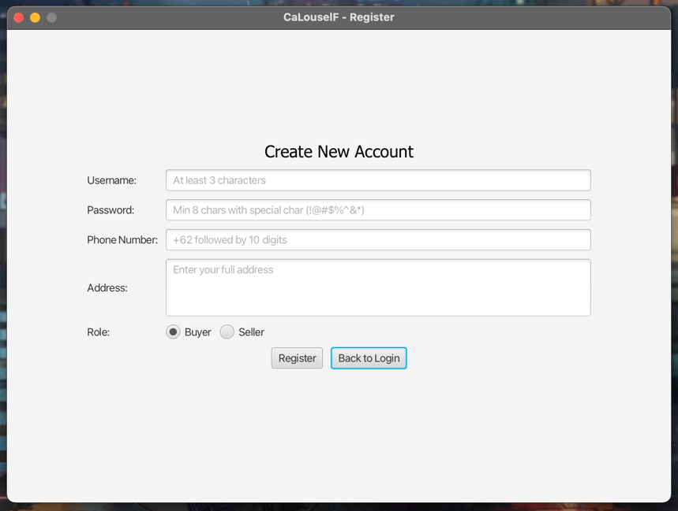

The registration system includes comprehensive validation:

* Username: Minimum 3 characters
* Password: Minimum 8 characters with special character requirement (!@#$%^&*)
* Phone Number: Must start with +62 followed by 10 digits
* Address: Required field
* Role Selection: Buyer or Seller

1. **Seller Dashboard**

Sellers can manage their inventory through:

* Item listing with status indicators (pending, approved, declined, sold)
* Edit and delete functionality for approved items
* Color-coded status display
* Refresh capability for real-time updates

1. **Admin Dashboard**

Administrators have access to:

* Pending item review queue
* Approve/Decline buttons
* Reason input field for declined items
* Clear status indicators

1. **Buyer Features**

Buyers can interact with the platform through:

* Browse available items
* Add items to wishlist
* Make purchase offers
* Direct purchase option

1. **Wishlist Management**

The wishlist feature includes:

* Saved item display
* Item details with pricing
* Remove from wishlist functionality
* Easy access to purchase options

1. **Purchase History**

Transaction tracking includes:

* Complete purchase history
* Transaction timestamps
* Item details and pricing
* Chronological ordering

1. **Offer System**

The offer system provides:

* Current price display
* Highest offer indication
* Offer submission interface
* Seller offer management
* Accept/Decline functionality with reason

1. **Item Management**

Sellers can manage items through:

* Upload new item
* Item details editing
* Price updates
* Category and size modification
* Save/Cancel functionality
* **Additional Assumptions and Implementation Details**

1. **Database Management**

* Automatic UUID generation for all IDs
* Cascading deletions for related records
* Transaction isolation for concurrent operations

1. **Security Considerations**

* Password hashing implementation ready
* Session management capability
* Input sanitization for all fields

1. **Performance Optimizations**

* Lazy loading for item lists
* Efficient query optimization
* Connection pooling ready
* **Usage**

1. **For Buyers**

* Register a new account with "Buyer" role
* Browse available items
* Add items to wishlist
* Make offers or purchase items directly
* View purchase history

1. **For Sellers**

* Register a new account with "Seller" role
* Upload items for sale
* Wait for admin approval
* Manage item listings
* Accept or decline offers

1. **For Administrators**

* Login with admin credentials (username: admin, password: admin)
* Review pending items
* Approve or decline items with reasons
* Monitor system activity
* **Installation**

1. **Clone the repository**

git clone https://github.com/reynaldomarchell/calouself.git

1. **Add JavaFX and MySQL Java Connection Library to the project**

Using Eclipse:

* Right click on project folder -> Build Path -> Configure Build Path...
* On Libraries tab, click on Modulepath -> Add Library -> User Library
* Check JavaFX and MySQL and then apply changes

1. **Set up the MySQL database**

mysql -u root -p < /[Documentation_SQL]/calouself.sql

1. **Configure database connection**

Update the database connection settings in connect/Connect.java

1. **Compile and run**

* **Build using**
* Eclipse Version 4.34.0 (2024-12)
* Java 23.0.1 (2024-10-15)
* JavaFX 21.0.4
* MySQL Java Connection Library 8.0.24
* XAMPP 8.2.4-0
* Reference
* **JavaFX Documentation**
* <https://openjfx.io/javadoc/21/>
* <https://docs.oracle.com/javase/8/javafx/api/toc.htm>
* **MySQL Documentation**
* <https://dev.mysql.com/doc/>
* <https://www.mysql.com/products/connector/>
* **Java Development Resources**
* <https://docs.oracle.com/en/java/>
* <https://docs.oracle.com/javase/tutorial/>
* Group Member
* 2602187664 – Stanislaus Kanaya Jerry Febriano
* 2602093992 – Valeska Valentin Ekklesia
* 2602093714 – Nicholas Vincent Chao
* 2602138214 – Reynaldo Marchell Bagas Adji